OTCR Consulting 1st Round McKinsey Case Interview
Timeframe (25-30 minutes)

This is part two of the three-part interview. This section is an initial test of their analytical ability and creativity. Through this portion, a candidate should exemplify the ability to form a structure to solve a problem, creatively think of potential solutions,

Problem: Our client, Store-It Co., is a small start-up specializing in storing college student’s possessions over the summer. They pick up possessions at the residence at the inception of the summer, and drop them off again at the beginning of school. Store-It Co. is looking to launch in the Champaign market, and their CEO has approached OTCR to understand whether this launch is worthwhile.

Follow-up Question #1: Before diving into any analysis, what would you first do to approach this problem and prepare to be on this project?
Possible Solutions: collecting data, understanding how many students need this service, understand competitor sales, customer segments, point of sale, etc.

Follow-up Question #2: What might be some challenges and opportunities that Store-It Co will face when entering the market?
Possible Solutions: high competition, low prices of existing storage spaces, loyal customers, etc.

Follow-up Problem: You bring your findings to the CEO and he is excited about the information. He states that the biggest worry the current leadership is having is that there is a competitor called SpareSpace currently operating on campus. They operate across several campuses, and thus have significant resources. The CEO wants to be a direct competitor to SpareSpace, but is unsure of the scale that they need. First, he needs to understand the size of the market.

Follow-up Question #3: What was the total market (in terms of revenue) for student possession storage on campus last summer? We believe that if a student chooses to store belongings, then the average weight of stored material is 70 lbs.
- This is a standard market sizing
  - Challenge their assumptions
  - Ask them if they think their math is right?
  - Force them to find ways to segment the market
  - Please see the accompanying Excel to sanity check their answer – this only represents one possible answer though

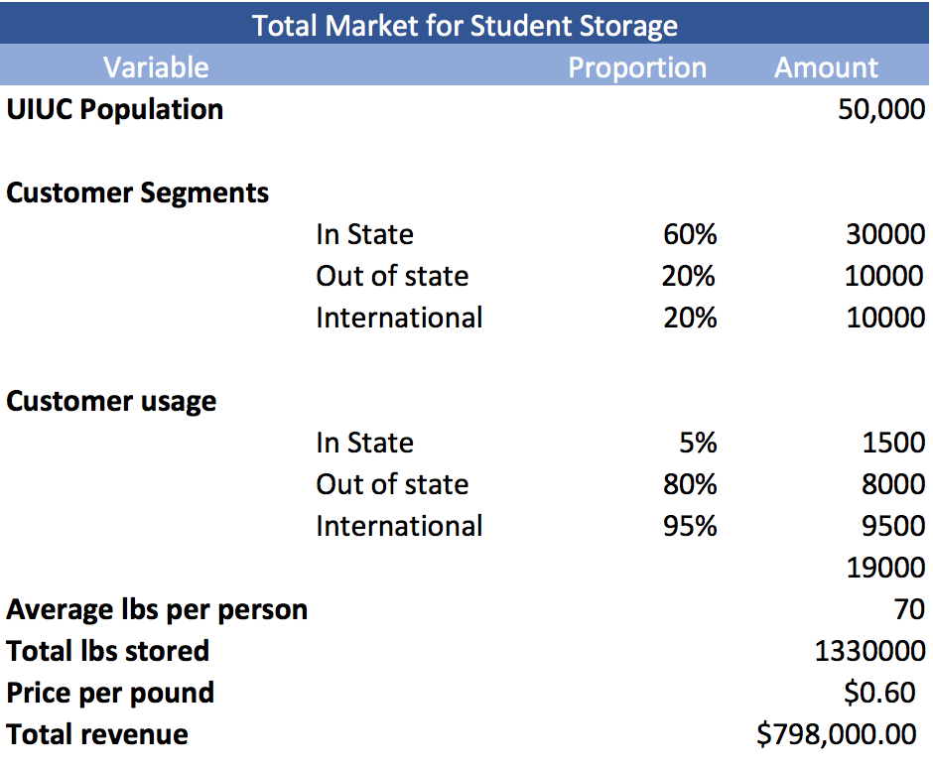

Follow-up Problem: The CEO likes your understanding of the student storage service market on the UIUC campus and feels that Store-It Co. has the potential to carve out a sizable portion of the market. Given that the opportunity is time-sensitive, the CEO has identified a couple of other areas that he would like explored.

Follow-up Question #4: When launching this service, how can Store-It Co. differentiate themselves from its competition such as SpareSpace and more traditional storage providers?
Possible Solutions: quality, service, guarantees, speed, price, flexibility, promotions, technology etc

Follow-up Question #5: What major cost drivers and potential revenue streams will Store-It Co. face or utilize when on campus?
Possible Solutions: labor costs, transportation costs, storage costs, reimbursement costs, maintenance costs, etc.; students, possible advertising of other services, cross-delivery services, etc (look for creativity here)

Follow-up Question #6: The CEO is walking into the room right now and wants your final recommendation on the expansion strategy. He has a meeting right after this, so please give him an update right away

